|  |  |  |  |
| --- | --- | --- | --- |
| Input | Expected Output | Actual Output | Pass? |
| Test Case #1  California,  Texas,  New York,  None | California  Bird: California Quail  Flower: California Poppy  Texas  Bird: Northern Mockingbird  Flower: Bluebonnet  New York  Bird: Eastern Bluebird  Flower: Rose  **** Thank You ****  A summary report for each State, Bird, and Flower is:  California, California Quail, California Poppy  Texas, Northern Mockingbird, Bluebonnet  New York, Eastern Bluebird, Rose  Please visit our site again! | California  Bird: California Quail  Flower: California Poppy  Texas  Bird: Northern Mockingbird  Flower: Bluebonnet  New York  Bird: Eastern Bluebird  Flower: Rose  **** Thank You ****  A summary report for each State, Bird, and Flower is:  California, California Quail, California Poppy  Texas, Northern Mockingbird, Bluebonnet  New York, Eastern Bluebird, Rose  Please visit our site again! | Yes |
| Test Case #2  WYOMING,  florida,  Nevada,  Idaho ,  none | WYOMING  Bird: Western Meadowlark  Flower: Indian Paintbrush  florida  Bird: Northern Mockingbird  Flower: Orange Blossom  Nevada  Bird: Mountain Bluebird  Flower: Sagebrush  Idaho  Bird: Mountain Bluebird  Flower: Syringa, Mock Orange  **** Thank You ****  A summary report for each State, Bird, and Flower is:  WYOMING, Western Meadowlark, Indian Paintbrush  florida, Northern Mockingbird, Orange Blossom  Nevada, Mountain Bluebird, Sagebrush  Idaho , Mountain Bluebird, Syringa, Mock Orange  Please visit our site again! | WYOMING  Bird: Western Meadowlark  Flower: Indian Paintbrush  florida  Bird: Northern Mockingbird  Flower: Orange Blossom  Nevada  Bird: Mountain Bluebird  Flower: Sagebrush  Idaho  Bird: Mountain Bluebird  Flower: Syringa, Mock Orange  **** Thank You ****  A summary report for each State, Bird, and Flower is:  WYOMING, Western Meadowlark, Indian Paintbrush  florida, Northern Mockingbird, Orange Blossom  Nevada, Mountain Bluebird, Sagebrush  Idaho , Mountain Bluebird, Syringa, Mock Orange  Please visit our site again! | Yes |
| Test Case #3  hawaii,  ORegOn,  missisippi,  Mississippi,  ArKaNSaS,  NONE | hawaii  Bird: Hawaiian Goose  Flower: Hawaiian Hibiscus  ORegOn  Bird: Western Meadowlark  Flower: Oregon Grape  missisippi  An invalid state was entered. Please try again.  Mississippi  Bird: Northern Mockingbird  Flower: Magnolia  ArKaNSaS  Bird: Northern Mockingbird  Flower: Apple Blossom  **** Thank You ****  A summary report for each State, Bird, and Flower is:  hawaii, Hawaiian Goose, Hawaiian Hibiscus  ORegOn, Western Meadowlark, Oregon Grape  Mississippi, Northern Mockingbird, Magnolia  ArKaNSaS, Northern Mockingbird, Apple Blossom  Please visit our site again! | hawaii  Bird: Hawaiian Goose  Flower: Hawaiian Hibiscus  ORegOn  Bird: Western Meadowlark  Flower: Oregon Grape  missisippi  An invalid state was entered. Please try again.  Mississippi  Bird: Northern Mockingbird  Flower: Magnolia  ArKaNSaS  Bird: Northern Mockingbird  Flower: Apple Blossom  **** Thank You ****  A summary report for each State, Bird, and Flower is:  hawaii, Hawaiian Goose, Hawaiian Hibiscus  ORegOn, Western Meadowlark, Oregon Grape  Mississippi, Northern Mockingbird, Magnolia  ArKaNSaS, Northern Mockingbird, Apple Blossom  Please visit our site again! | Yes |

Screen Capture of me using an IDE (Eclipse) to write my Java program:

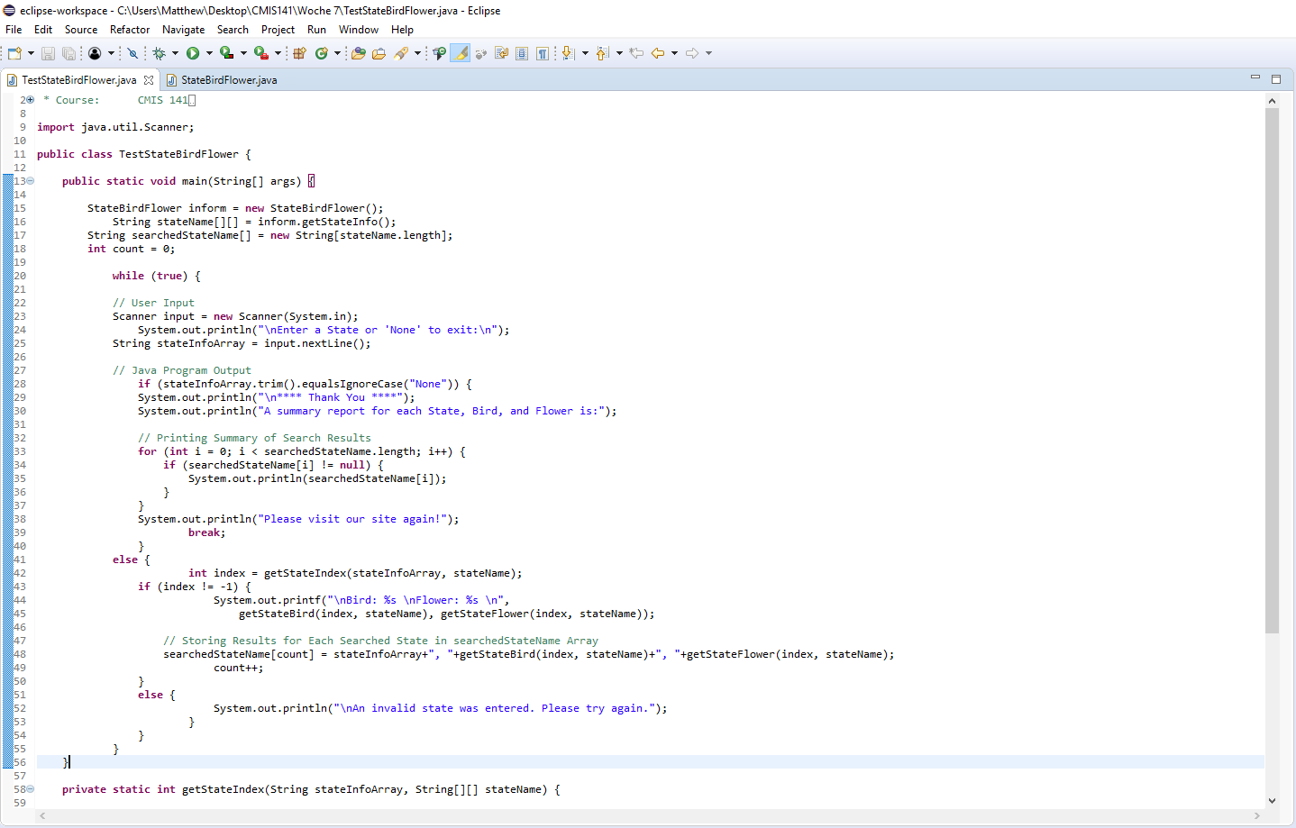

Screen Capture of me successfully compiling and executing my Java program:

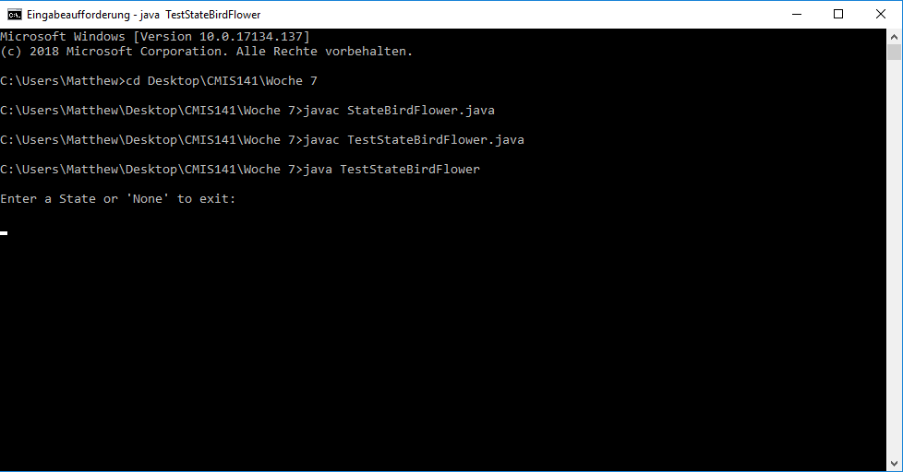

Screen Capture of Test Case #1:

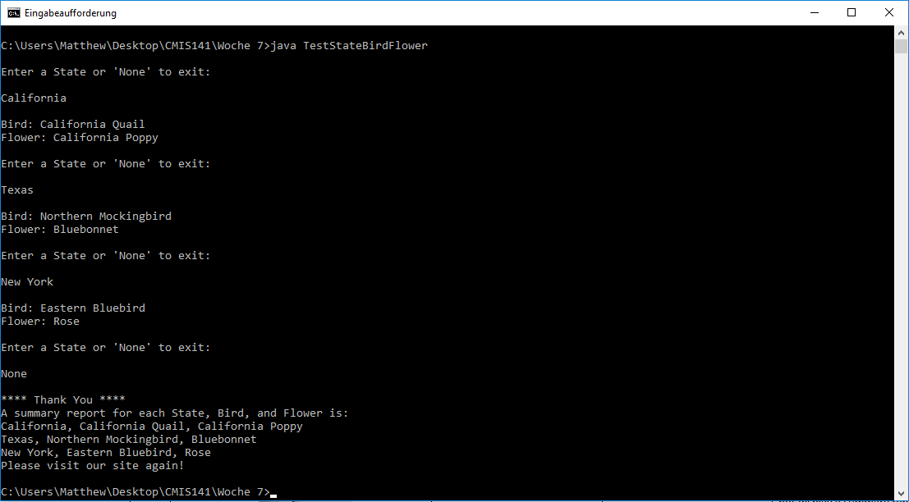

Screen Capture of Test Case #2:

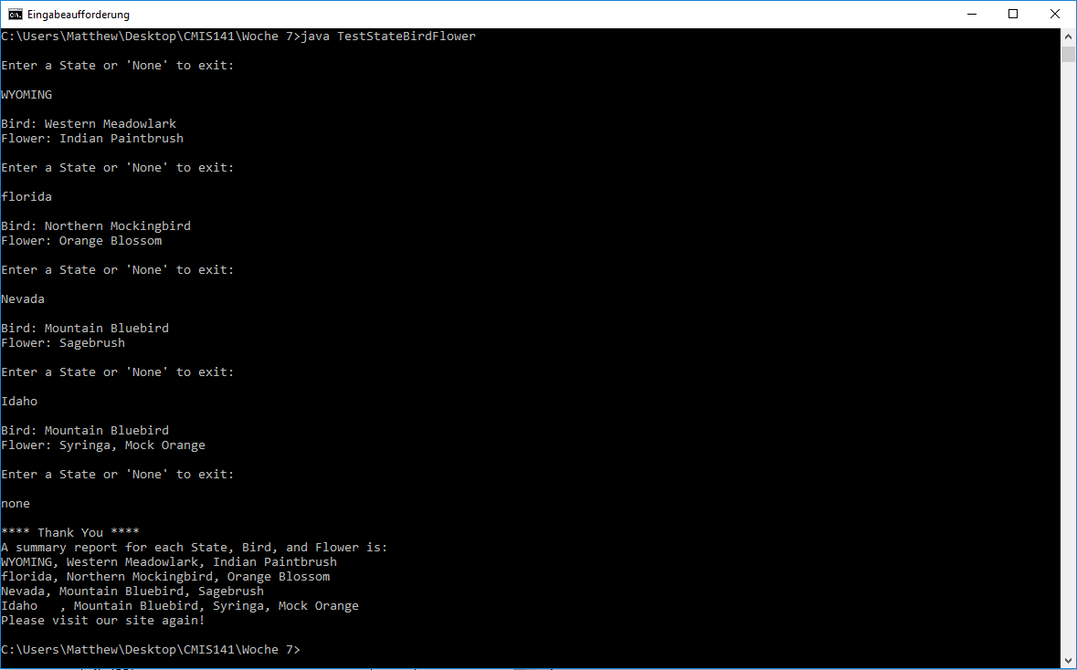

Screen Capture of Test Case #3:

